Patient’s Dental and Medical Records System of University of Antique Tario-Lim Memorial Campus

A Research Paper

Presented to

The Faculty of the College of Computer Studies

University of Antique

Tario – Lim Memorial Campus

Tibiao, Antique

In Partial Fulfillment of the Requirements

for the Course COMSC 10

By

Charity Grace L. Estoquia

Fedelyn P. Tiburcio

April 2023

**Patient’s Dental and Medical Records System of University of Antique Tario-Lim Memorial Campus**

**CHAPTER I**

**Background of the study**

University of Antique Tario-Lim Memorial Campus is one of the leading University in the province of antique. It composes of four colleges namely CCS, CBM, CTE and COFES. There are approximately more than 4 thousand enrollees. The school has many offices and one of that is the Dental and Medical clinic. It consists of physician, dentist, nurse, and dental aide. This clinic facilitates all transaction regarding to the health concerns of patient’s inside the campus. The clinic still uses paper –based or manual recording to gather information of patient’s medical and dental history profiles along with the laboratory and the treatment process. Moreover, there were instances that files are misplaced, and worst, files are lost due to not having a digital storage that can hold the files together.

One of the fundamental principles to the dental and clinical ethics is that all information which passes between a doctor and patient in the course of a professional relationship is confidential. This principle is according to Republic Act No. 10173also known as the Data Protection Act, a law that seeks to protect all forms of information, be it private, personal, and sensitive which regulates the collection, processing and disclosure of personal data, and intends to protect against its misuse. It is meant to cover both natural and legal persons engaged in the processing of personal information.

The researchers proposed a system to develop the Patient’s Dental and Medical records that improves the paper-based or manual recording of every patient’s in University of Antique Tario-Lim Memorial Campus. This system helps school clinic to easily locate the data files as it is more organized, and secure. The records include patient’s personal information, official health records, medical and dental history. This system aims to make it easy to document patient’s medical histories and transmit data between patients. The goal of this system is to decrease the use of paper, make it easy to gather and retrieve patient data file, and secure the integrity of every patient or student.

**Statement of the Problem**

The developers have recognized the need for the development of a Patient dental and Medical Record System of University of Antique Tario-Lim Memorial Campus with the following problem.

1. The school clinic is still using manual process of recording information that consumes time.
2. The school clinic doesn’t have digital repository which results to misplaced or missing files.

**Objectives of the Study**

The following are the general and specific objectives that this proposed study seeks to achieve.

**General objectives**

The general objective of the study is to design and develop a Patient’s Dental and Medical Records Management System for the University of Antique Tario-Lim Memorial Campus, Tibiao, Antique.

**Specific Objective:**

Specifically, this study seeks to:

1. Integrate a subsystem that could manage and store patient’s record;
2. Create a subsystem that enables the school nurse and doctor to efficiently record, update, and retrieve patient’s records; and
3. Test the developed system characteristics based on ISO 25010 standards.

**Significance of the Study**

This study will be helpful to aim the current manual method of the School clinic in University of Antique Tario-Lim Memorial Campus. The most important thing is that the system was made for easy retrieval of information and stores the complete records of the patients. For the security, before the user enters the system they need to input the user name and password they are creating. This system had different access for the difference user. For the management of the clinic, they may view the daily report of clinic. The clinic management system will process for both dental aide and the patient.

The following individuals are the beneficiaries of the study:

**Clinic staff**

They will no longer manually search, update and write the student’s record which takes more time and effort.

**School Doctor and Nurse**

The study benefits the doctor in retrieving past and previous records of the students in a very well-organized way by just searching the records automatically.

**Students**

The students can get hold of their records faster in case they need it for significant purposes.

**Scope and Limitations of the Study**

The study entitled “Patient’s Dental and Medical Records System of University of Antique Tario-Lim Memorial Campus” is a system that improved the paper-based records of the dental and medical records of every students of University of Antique Tario-Lim Memorial Campus. This is the following scope of the study to be followed by the limitation of the study.

1. The system will replace the manual method of documentation that is currently used of University of Antique Tario-Lim Memorial Campus.
2. The system will efficiently be organized, manipulate the student’s records especially like editing and adding, viewing, deleting, and especially securing the confidential records of every students.
3. This system will serve as a record of every patient who had a consultation with the doctor, nurse and dental aide inside of the school.
4. This system provides fast and precise reports. It lessens the time and effort used by the doctor, nurse, dental aide and staff.

**These are the limitation of the study;**

1. The system is only for the school clinic only doctor, nurse, dental aide and staff is allowed to operate or use this system.
2. This system are for students who is already registered can access.

**DEFINITIONS OF TERMS**

User-friendly. As used in the study, this term refers to the simplicity of using the program.

Reliability. As used in the study, this term refers to the good functionality of the system.

Effectiveness. As used in the study, this term refers to the capability of producing a desired output.

Accuracy- As used in the study, this term refers to the quality of being exact or precise.

Records Management System. This refers to the computerization of patient records. A software application for managing records data.

Record. As used in the study, this term serve as information that is being registered in the system if the patient is new.

Patient. As used in the study, this term serves as a recipient of health care service: a person who is ill or is undergoing treatment for diseases.

System. As used in the study, this referred to the process, where in the hardware and software work together to run a program.

**CHAPTER II**

**RELATED LITERATURES**

**Online Clinic Management System**

As people become more educated, hence people become more aware of the quality of their life especially something that is related toward their health. The poor service in health care would give an effect towards the development of our country. To receive a treatment from government hospitals, patients sometimes need to wait for hour’s .While for administration's task they need to keep track a huge number of filing where all details on patients were being kept, sometimes it leads to data redundancy and .an additional workload. That is why Online Clinic Management System is being proposed and this proposed system is develop using a web-based, concept. The method used to develop the system include iterative waterfall model approach, dataflow, logical and entity relationship diagram were used to design the system. With the existence of this system the registration process would avoid data redundancy, records keeping on patient details can be find faster and time waiting for patient before received a treatment from doctor could be lessen,, this is because all manual task that happen in this system is being convert to computerized type of system.

**A Computerized Patient’s Database Management System**

Healthcare in Sierra Leone faces major dilemma when it comes to recording keeping with high demand for medical treatment and services. The medical records must appropriately have all of the patients’ medical history. Healthcare professionals should always find a way to maintain the physiological parameters that can be referenced when the need arises as it can be used for several purposes. This study on patient’s database management system is design to transform the manual way of searching, sorting, keeping and accessing patient medical information (files) into electronic medical record (EMR) thereby eliminating the traditional system. Existing platforms (manual systems) have been critically examined and hence a computer based system is essential for optimal result. The computer-based platform produces patient’s records that enhances medical practioner’s to constantly monitor their patients daily in and out of the hospital. The research looks for a more reliable and efficient scheme via computer technology to process patient health record ensuring proficient outcome that is cost-effective, save time and speed-up treatment. The research proposed patient database as an alternative solution to the growing world population especially third world nations. The system will serves as a communication tool thereby easing an efficient transfer of patient medical data to healthcare professionals for effective supervision within and outside the hospital. Furthermore, it also accelerates the transfer of patient healthcare data to healthcare medical servers or individual such as insurance company or employer. Efficient storage of medical records renders accuracy diagnosis that enhances reliable and detail prescriptions which can be referenced as it is needed.

**DESIGN AND DEVELOPMENT OF ONLINE HOSPITAL MANAGEMENT INFORMATION SYSTEM**

Computers are finding their way into every business, industry and research activity today. The use of computers is diverse such as entertainment, education, problem solving, research, personal management, etc. In hospitals, the process of maintaining the record of patients and employees working in the hospital, calculating bills, etc., requires processing and record keeping in different departments. Keeping in view a strong need for managing the above information fast and efficiently, Online Hospital MIS has been designed and developed. It is user friendly and provides simple and efficient way for managing the working of hospitals. It has been developed using .NET Framework. The database has been secured as only authorized personnel can modify the data. The database has been designed using Microsoft SQL Server 2000 as the back-end and the application has been developed using ASP.NET 2.0 as front-end. SQL Client data provider has been used to provide database connectivity. The software provides better speed and performance than the traditional hospital management system.

**Design of a Web System for the Administrative Control of the Medical Records in a Health Center**

Many healthcare facilities do not have a system for monitoring patient medical records, which leads to one of the biggest conflicts for nurses and patients, as there is a great deal of information loss and data redundancy. To prevent such problems it is necessary to implement a web system, which organizes the medical records of each patient in a dynamic and continuous way. This work was carried out with the Scrum methodology, which is characterized by carrying out small and large projects in a given time, resulting in an efficient system. In this case study the four Sprint were determined, which are intended to be carried out by modules. The results of this application would have the diagnostics in an immediate time. The results obtained could help doctors, nurses, patients and mainly health centers to better diagnose the patient, optimizing the service and the control of information

**Design and Implementation of a Secured Web based Medical Record Management System: A Case Study of Federal University Wukari (FUW) Clinic**

Patient records constitute the bulk of the medical records of almost all the health care centers all over the world; The existing system of medical record keeping used in FUW Clinic is predominantly paper-based and it is associated with problems such as misplacement of patients’ record, unnecessary duplication of patients’ record as well as lack of effective back up facilities. In an attempt to address the problems associated with paper-based medical record, this project aimed at automating the whole processes by designing a web-based application to minimize the cost of procuring stationery materials needed for paper-based record keeping and enhancing the integrity and security of the patients’ medical records. The proposed system uses the following security tools to prevent unauthorized users from gaining access to the system resources: The sign up module, the security measure employed on the sign up module to ensure that no unauthorized person is allowed to create a user account is that when a user clicks on the sign up button a prompt will be displayed asking the user to enter a One Time PIN (OTP) which is only obtainable from the appropriate authorities of the clinic. Another security tool used is the encryption of user’s password on the login tables using the MD5 encryption function, once a user submits a new user account details during the sign up processes, the user’s password will be posted to the login table in an encrypted format. To achieve these objectives, the technologies used in the development of this automated system were: HTML, CSS, Javascript and PHP as the Scripting languages, MySQL as the database engine. The system grants different users privileges based on their statutory functions in the clinic which allow the clinical staff (users) the view and perform actions strictly within the domain of their official duties.

**Prior Art**

**METHOD AND SYSTEM FOR MAINTAINING COMPUTERIZED DENTAL RECORDS**

[**WO0180117A1**](https://worldwide.espacenet.com/patent/search?q=pn%3DWO0180117A1)

The present invention is a method and system for managing patient dental records in a computer database via a global computer network. A dentist enters at least one patient dental record into the database via the global computer network and designates other users who may access the record. After an initial authorization, a patient user is directed to the home page of the dentist who provided the patient authorization code to the patient user. From this dentist home page, the patient user may enter any of several different section, including Patient General Chart (310), Reference Zone (320), Pharmacy Zone (330), Search (340), Help (350), and General IDT Information (360). Once the patient enters the Patient General Chart (310) section, the patient user may access various areas relating to his or her dental record, such as Medical/Dental History (312), General Exams (314), and IDT Charts (316).

**Medical and dental software program**

[**US2004236608A1**](https://worldwide.espacenet.com/patent/search?q=pn%3DUS2004236608A1)

A medical and dental software program that generates computerized data reports and patient progress notes based upon information gathered from testing and from patients' personal and medical information. The medical and dental software program generates reports based upon information gather from diagnostic testing systems currently in use, inclusive of, but not limited to visual, physical, radiographic, laser, pulp testing, microscopic, biopsy, CT scan, MRI, electron beam and blood analysis. The medical and dental software program is designed to integrate future diagnostic systems (in the form of modules) that are under development or in current use in specialty fields of medicine. The program compiles the reports and integrates them into a computerized patient progress note, which is the document format that is used in the medical and dental professions. The program utilizes human anatomic forms (anatomic fields and anatomic grids) that represent a particular organ or body part—i.e. the mouth, the oral/facial complex, the brain, heart, lung, kidney and alike to aid in the input of patient data. The anatomic forms are used by the practitioner to enable them to easily enter relevant medical diagnostic data into the system. Each grid and/or field contains a series of subparts that allow the practitioner to enter specific detail with regards to a particular organ or body part. The findings such as normal, a variation of normal and pathologic are subparts a practitioner would find upon examination or interpretation of a particular organ or body part. From those findings entered into the program, the practitioner can form a diagnosis, treatment plan, document the treatment and subsequently generate a report.

**System for Maintaining Patient Medical Records for Participating Patients**

[**US2006206361A1**](https://worldwide.espacenet.com/patent/search?q=pn%3DUS2006206361A1)

A portable heath care records system employs a server on which the health care records of participating patients are stored. The patients may access the system using cards or CD-ROMS that are inserted into the patient's computer. The patients can review their own records via Internet and can edit them. The patient may also access via cell phone or handheld device. The patient record is protected by patient ID and password. Treating physicians have access to each patient's records for review and update. A two-way firewall permits patients to review their own health records only, but permits the physician to review both the physician files and the patient files. The physician can override the firewall to send patient information from his or her record. A read-only emergency screen with medical data about the patient may be accessed for emergency use. Records of many patients and of many clinics are maintained on a common server, so that the patient record can be accessed globally.

**Summary**

Online Clinic Management System is proposed to improve the quality of health care in the country, avoiding data redundancy and additional workload. While A Computerized Patient’s Database Management System study aims to transform the manual way of searching, sorting, keeping and accessing patient medical information (files) into electronic medical record (EMR). And also Design and Development of Online Hospital Management Information System is user-friendly and secure. It provides better speed and performance than traditional hospital management systems. Additionally Design of a Web System for the Administrative Control of the Medical Records in a Health Center was used to design a web system to organize patient medical records in a dynamic and continuous way, allowing doctors, nurses, patients and health centers to better diagnose and control information. Lastly The Federal University Wukari (FUW) Clinic has implemented a web-based medical record management system to reduce the cost of paper-based record keeping and enhance the integrity and security of patients' medical records.

|  |  |  |  |  |
| --- | --- | --- | --- | --- |
| OVERVIEW OF THE REVIEW SOURCE  **TABLE 1** | | | | |
| Research Title and Author | Country  Origin | Purpose/Objective | Type Resource | Summary Points |
| **Online Clinic Management System**  Teke, A., Londh, S., Oswal, P., &Malwade, S. S. (2019). Online Clinic Management System. International Journal (Toronto, Ont.), 4(2). | Toronto | Online Clinic management system is a computerized patient record system. The main purpose of the system is to reduce the burden of doctor and nurses and improve the patient records management; system integrates clinical, scheduling, electronic medical records, charting and data reporting components that enable clinics to provide patients with quality care. | Journal | The proposed system will bring benefits to doctors and nurses. Much workloads and planning can be schedule more effectively. It is aims to assist users in achieving their respective goals and objectives. |
| **Design And Development of Online Hospital Management Information System**  Kaur, H., & Grover, D. (2013). Design and Development of Online Hospital Management Information System. International Journal of Computer Science Engineering and Information Technology Research, 3(2), 79-88. |  | The objectives of the system are;  To maintain the record of indoor and outdoor patients  To computerize the records of employees working in the hospital, including their financial aspects  Automation of billing of patients  Management of Hospital Stock Inventory | Journal | The system is secure and highly user friendly also it provides simple and efficient way for managing the working of hospital. The Objective of the has been achieved successfully. |
| **Design of a Web System for the administrative control of the medical records in a Health Center**  Delgado, A., &Sarai, A. A. (2020). Design of a web system for the administrative control of the medical records in a health center. International Journal, 8(6). |  | The purpose of this web system is to monitor patient medical records, which leads to one of the biggest conflicts for nurses and patients, as there is a great deal of information loss and data redundancy. And also to organizes the medical records of each patient in a dynamic and continuous way. | Journal | The application proved to be effective in terms of patient history consultation’s, which generates possible solutions and automatic reports of individual patient histories and diagnoses made in a given time. |
| **Design and Implementation of a secured Web based Medical Record Management System: A Case Study of Federal University Wukari (FUW) Clinic**  Joseph, B., Gadzama, W. A., &Agu, E. O. (2020). Design and Implementation of a Secured Web Based Medical Record Management System: A Case Study of Federal University WUKARI (FUW) CLINIC. International Journal of Computer Applications, 177(41), 27-33. |  | The purpose of this systemweb-based application is to minimize the cost of procuring stationery materials needed for paper-based record keeping and enhancing the integrity and security of the patients’ medical records. |  | As far as this research project is concerned, patient records constitute the bulk of the medical records of all the health care centers all over the world; to this effect, medical records refers to the confidential information kept for each patient by heath care professionals or organizations that contains the  patient’s personal details such as name, residential address, and date of birth, a summary of the patient’s medical history and documentation of each event including symptoms, diagnosis, treatment and outcome; it also contains a report of the results of a medical examination of a patient. |
| **A Computerized Patient’s Database Management System**  Sawaneh, I. A., Kamara, A., &Koroma, J. H. (2018). A computerized patient’s database management system. Int. J. Comput. Sci. Inf. Technol. Res, 6(2), |  | The purpose ofthe study on patient’s database management system is design to transform the manual way of searching, sorting, keeping and accessing patient medical information (files) into electronic medical record (EMR) thereby eliminating the traditional system. | Journal | The research presents a patient medical record system that can be manipulated (sort data, data handling, search, update and store patient medical records securely). It reduces paperwork, reduces time spent by patients in the course of waiting for their files to be retrieved, reduce the storage space, increase the transmission rate of data flow, it is cost-effective and possible reduce hospitalization by allowing patient to be monitored by healthcare professionals whilst at home or at work. |

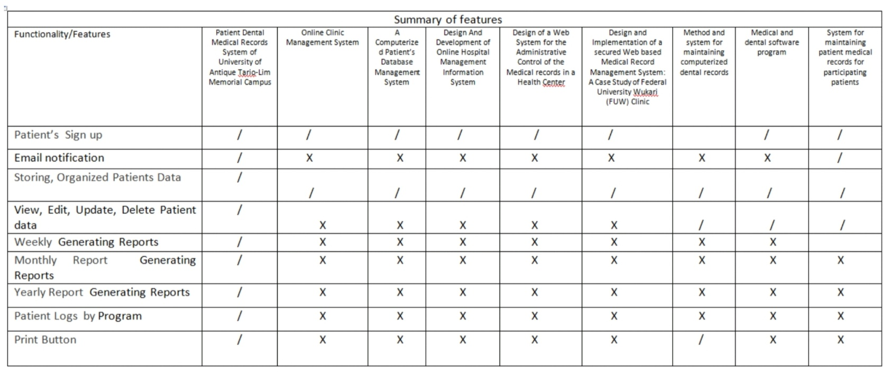**Table 2**

**Conceptual Framework**

|  |  |  |
| --- | --- | --- |
| **INPUT** | **PROCESS** | **OUPUT** |
| User Log   * User name * Password   Student’s Details   * Student ID * Name * Gmail * Year Level and Section * Age * Address * Sex * Contact number   Type of Forms   * Student health records * Individual patient’s record & summary of service rendered * Referral form * Refusal and care against medical advice * Medical clearance * Over-the-counter medicine and treatment form * Consultation * Medical examination | * Verification of user name and passwords * Verification of Patient’s details * Compiling of Patient’s records | * Patient’s Dental and Medical Records System |

**CHAPTER III**

**METHODOLOGY**

**Purpose of Research**

The purpose of this study is to design and develop a system Patient’s Dental and Medical Records at the University of Antique Tario-Lim Memorial Campus. In this chapter describe the model, user design, sampling method and instrument used to develop the system.

**Research Method**

In this chapter we used the Agile Model during this study. **Agile Software Development Life Cycle (SDLC)** is the combination of both iterative and incremental process models. It focuses on process adaptability and customer satisfaction by rapid delivery of working software product. Agile SDLC breaks down the product into small incremental builds. These builds are provided into iterations.

**Developmental Stages**

In Agile Model the development of study is divided into 7 stages. The proponents use this model for it is understandable and easy to use, every phase contains feedback path to its previous phase, simple to make changes or any kind of modification at any phase. By using this model, the developers can complete the project earlier.

**1st Stage: Planning**

In this phase, the developers collaborate to identify the tasks that must be finished, choose the programming language that will be used to develop the system, classify them according to their value and complexity, calculate the time needed to complete each task, and identify the dependencies between tasks. It is a continuous process, and the developers continually evaluate and modify the strategy to take into account shifting priorities or requirements. Our general objective is to design and develop a Patient’s Dental and Medical Records Management System for the University of Antique Tario-Lim Memorial Campus, Tibiao, Antique. Somehow, this will improve the paper-based procedures for locating patients records, and, most importantly, avoiding data loss. It is strongly recommended to assign and train the Dental Aid as a permanent user of the system. There will no need much of the man power for the system will help in providing the convenient way of dealing transaction. With the new system, it could manage store patient’s data and enables the school nurse and doctor to efficiently record, update, and retrieve patient’s records. There will be no more loss of data and no more delay for the finding of data for a specific patient. Definitely, the system aims to speed-up the record process more organized, secured and accurate.

**2nd stage: Design**

The design phase is where developers come up with a solution that satisfies the requirements of the customers while also being adaptable and flexible enough to deal with changes that might occur throughout the project. The developers would like to create a simple, attractive, and useful design.

Figure 1: Flowchart of Patient’s Dental and Medical Record System of University of Antique Tario-Lim Memorial Campus

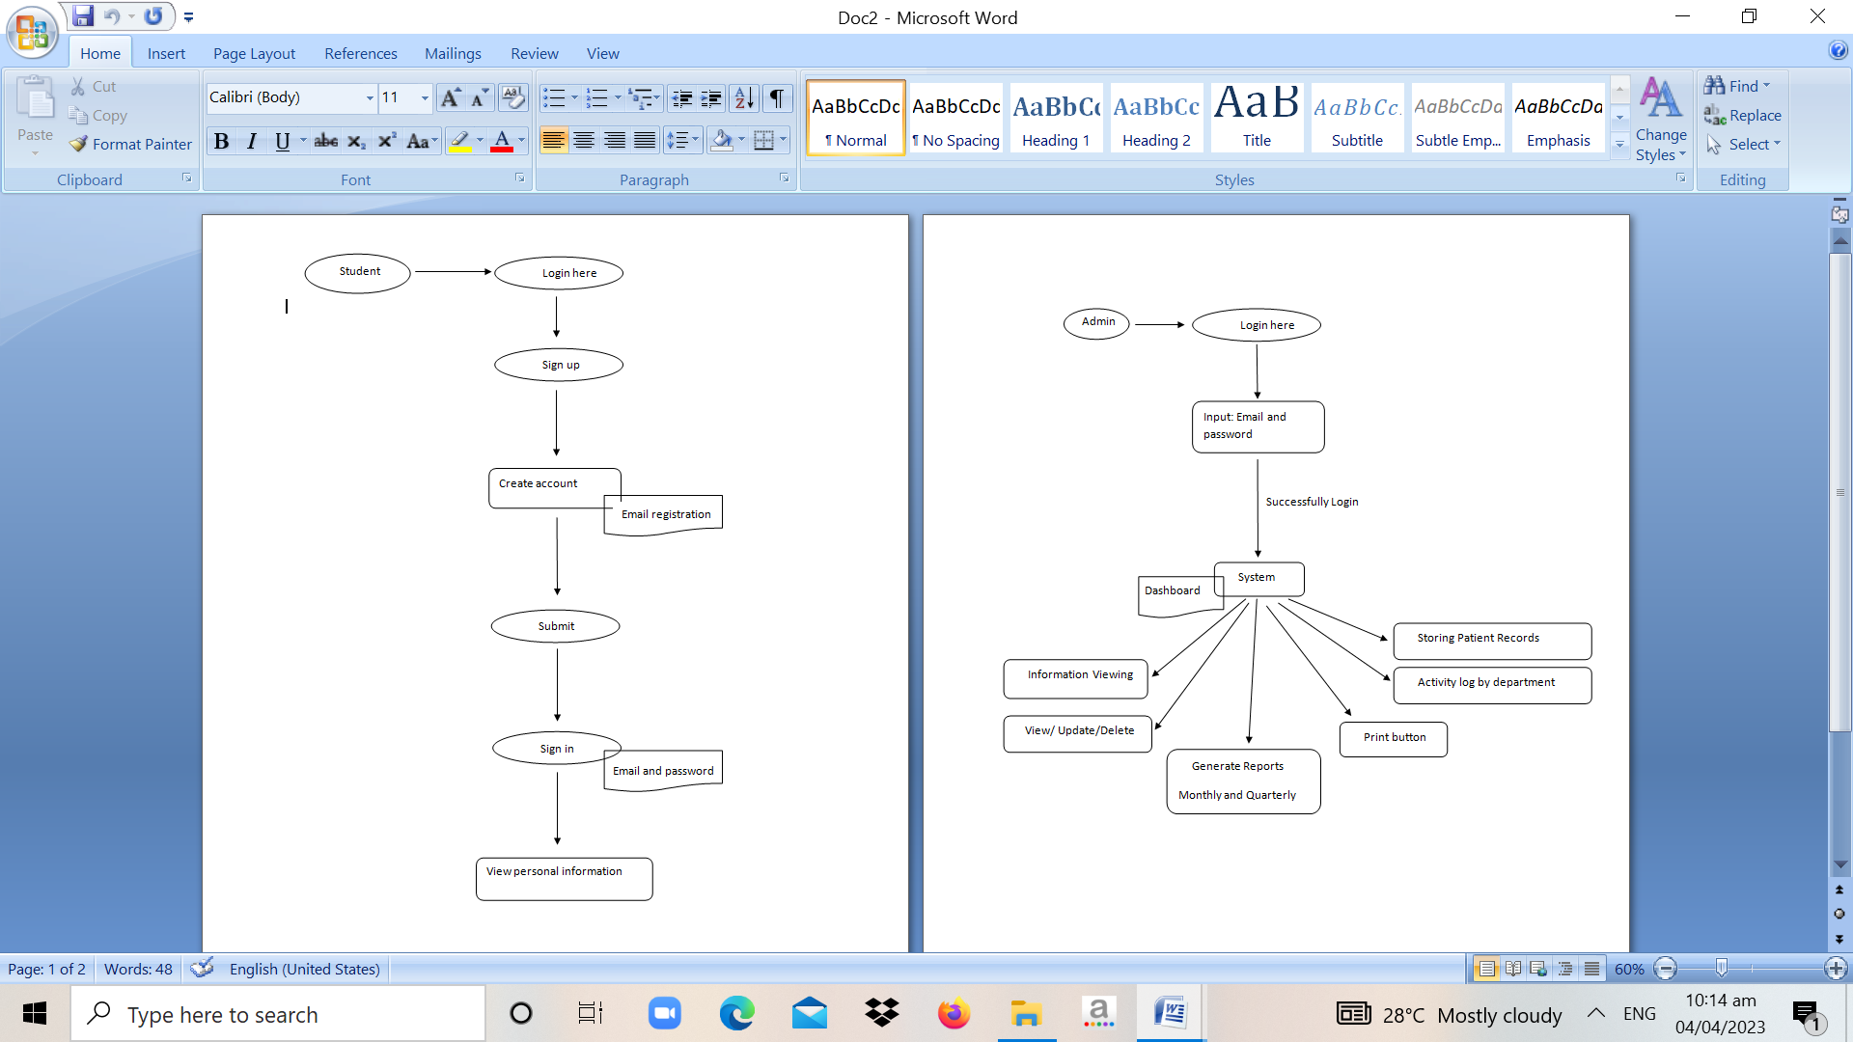



**Patient’s Medical and Dental Record System**

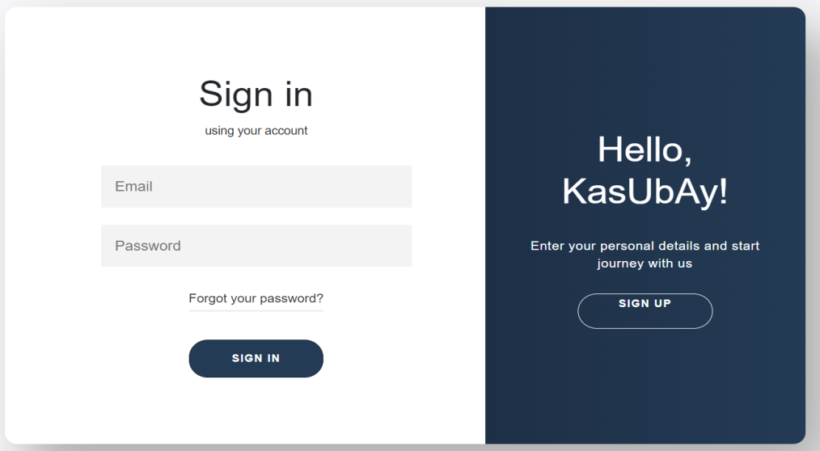

**Figure 1: Sign In form**

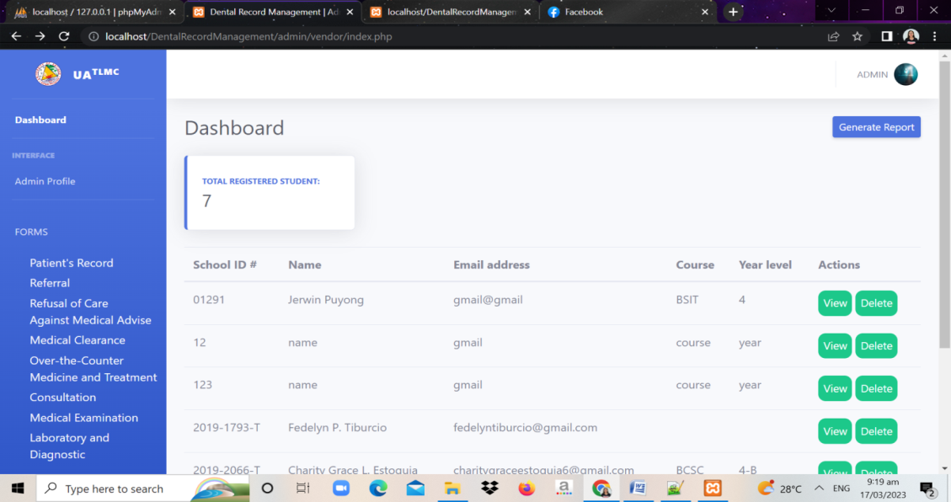

**Figure 2: Patient Record Table**

**Context Diagram**

Patient

Sending notification through email

Information/Data

View/Update

Log in credentials

Admin

**Use case Diagram**

PATIENT RECORDS

UPDATE/VIEW/PRINT INFORMATION

ENCODE INFORMATION

MANAGE SYSTEM

ADMIN

MONITOR STUDENT REGISTER

REGISTER USER

PATIENT DETAILS

USER

GENERATE REPORTS

**Data Flow Diagram**

**Patient**

**Dental Aid**



**View/update**

**Data/Information**

**System**

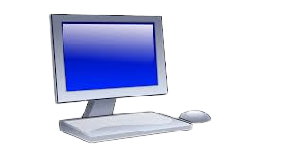

**Generate**

**Printer**



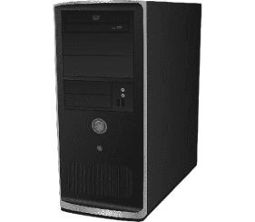

**Data base**

**Notification**

**3rd Stage: Develop**

This stage is where the developers have defined the requirements. Using the design produced during the design stage, it is where the developers collaborate to achieve the task during the planning stage. It usually involves writing code, where developers use the design chosen during the planning and design stages. Refactoring is a process in which developers examine the code to find potential areas for improvement or optimization. It also entails enhancing current code without altering its usefulness or behavior.

**4th Stage: Test**

In this stage the main goal is to make sure the system will meet the necessary quality standards as well as the customer's demands and expectations once it has been established. It involves a variety of testing procedures, such as automated testing, regression testing, and acceptability testing. The developers work on the defective codes and correct them as quickly as feasible after they are discovered during testing, which also includes defect management.

**5th Stage: Deploy**

This stage the developers check that the system is operating properly and adhering to the standards before deploying it. The developers additionally carry out acceptance testing to make sure the system satisfies the client's requirements. Additionally, it involves the product being monitored by the developers, who check for any problems or flaws and fix them as necessary.

**6th Stage: Review**

This stage of the development process is crucial. It is here that the developers review their earlier work to make sure it meets up to the client's requirements. The team can make the required adjustments to guarantee that the product is delivered on time by analyzing the work completed thus far. To make sure that all requirements are complete, current, and in line with the expectations of the client, developers also go over the product backlogs.

**7th Stage: Launch**

The system's implementation phase will be covered in this stage. The system will be made available to end users there. To ensure its quality, an evaluation will be performed. The eight qualities of the software product will be measured for the system using the ISO/IEC 25010 standard.

**Stage 3: Construction**

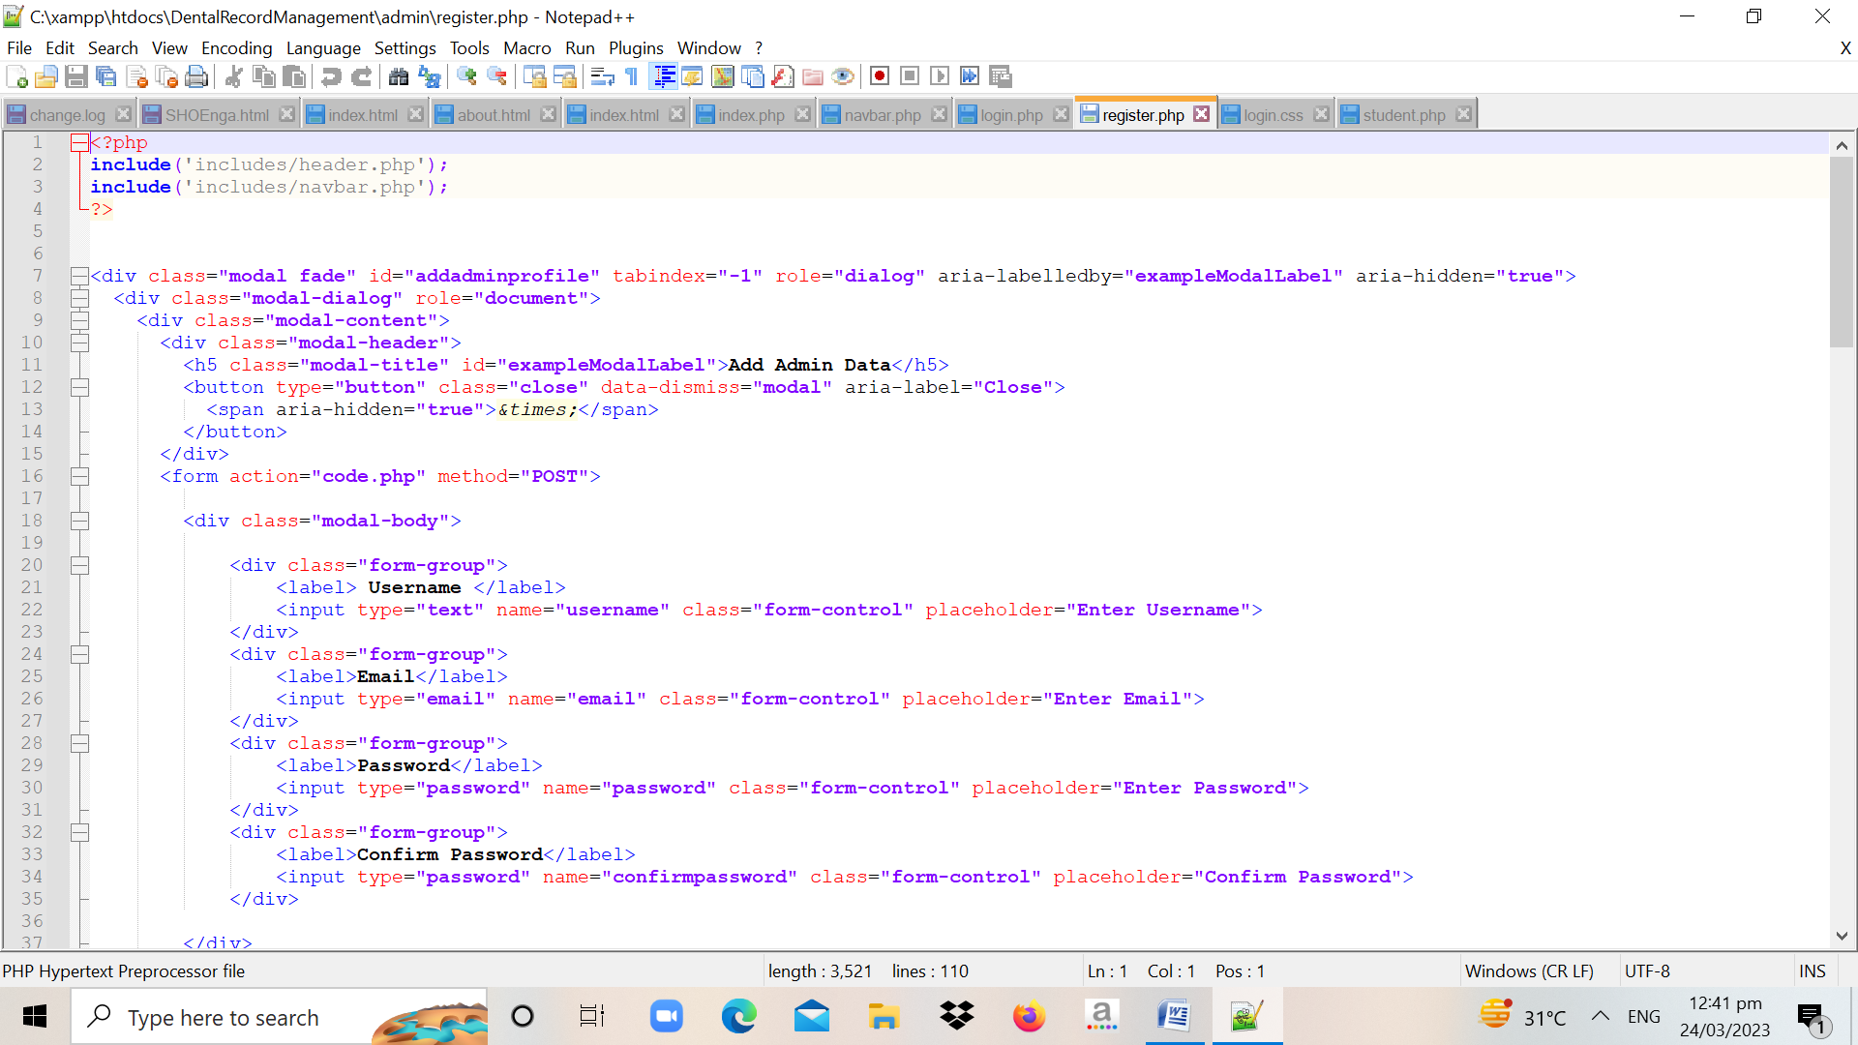

**Instrument of the Study**

Based on the interview that we conducted, the school nurse of University of Antique Tario-Lim Memorial Campus Clinic, the problem that they face right now is they still uses paper-based method that the patient needs to complete the details in registration form that doesn’t provide a backup, misplace patients past records information, difficult to locate the record of the patient’s, but their main problem is difficult to retrieve patient’s personal records.

**Stage 4: Cutover**

This stage will cover the implementation phase of the system. To measure its quality, an evaluation will be performed. The system will be evaluated using the ISO/IEC 25010 to measure the eight characteristics of the software product.

**Evaluators:**

The system will be evaluated by 30 evaluators represented in the table below:

|  |  |  |
| --- | --- | --- |
| Respondents | N | % |
| Health Service Unit | 6 | 20 |
| Faculty and Staff | 10 | 33.33 |
| Students | 10 | 33.33 |
| Panelists | 4 | 13.33 |
| Total | 30 | 100 |

Evaluators

Total of 30 Evaluators:

* 6 Health Service Unit
* 4 panelists
* 10 faculty/staff of University of Antique Tario-Lim Memorial Campus of College of Computer Studies
* 10 students of University of Antique Tario-Lim Memorial Campus.

**Dataset**

Description of dataset variables:

|  |  |  |  |  |
| --- | --- | --- | --- | --- |
| User | Program | Type of Forms | Frequency of Generating Reports | Information Viewing |
| Admin |  | * Student health records * Individual patient’s record & summary of service rendered * Referral form * Refusal and care against medical advice * Medical clearance * Over-the-counter medicine and treatment form * Consultation   Medical examination | Monthly  Quarterly | * System   Viewing   * Printed copy |
| Students | BSIS  BSIT  BSCS  CBM  COF  BSE  BSED  BEED  BLGA | * Student ID * Name * Gmail * Year Level and Section * Age * Address * Sex * Contact number |  |  |

**Research Instrument**

To gather the appropriate data needed in the study, the researcher conducted an unstructured interview towards the current problem that the clinic encountered in terms of using manual process operation to monitoring records.

**Data Collection Procedure**

The interviewee is shown the consent letter, provided a brief explanation, and given a copy. To gather detailed information on the topic, unstructured interview was conducted. The interview instrument was used to guide the interviewers. The first part inquired about the problems that they encountered in the clinic. The second part is they provide possible solution to the problems they encountered.

**Data Analysis Procedure**

After conducting the interview, the next step is to analyze the answers of the respondents. A proper analysis is important for the validity of the results. For an unstructured interview, a thematic analysis is used. Thematic analysis is a method of analyzing qualitative data. It is usually applied to a set of texts, such as an interview or transcriptions. The researcher closely examines the data to identify common topics, ideas and patterns of meaning that come up repeatedly.

**Ethical Considerations**

Prior to the conduct of the study, a letter asking permission to conduct an interview was handed out to the dental aid. All the results gathered in this study will be treated with utmost confidentiality. The dental aid’s duty is to protect the rights, welfare, and health of all patients, including those involved in this research. The physicians who are involved in the research have a responsibility to safeguard the life, health, dignity, integrity, right to self-determination, and privacy of study subjects' personal data.